**System Design Document**

**For**

**RF Direction Detection**

Team members:

Abigail Butka

Cassandra Harrison

Sofia Mvokany

Kyle Reagan

Sabrina Yepez

|  |  |
| --- | --- |
| Version/Author | Date |
| 2.1.1/Sabrina Yepez | 02/16/2021 |
| 2.1.2/All | 02/17/2021 |
| 2.1/All | 02/18/2021 |
|  |  |

TABLE OF Contents

￼

￼

￼

￼

￼

￼

￼

￼

￼

￼

￼

￼

￼

￼

￼

￼

￼

￼

￼

￼

￼

￼

￼

￼

System Design Document

# INTRODUCTION

## Purpose and Scope

This document describes the system requirements, operating environment, system and subsystem architecture, files and database design, input formats, output layouts, human-machine interfaces, detailed design, processing logic, and external interfaces for the RF Direction of Arrival system. The system is essentially a rotating loop antenna functioning in the 33-cm RF band that will determine the Direction of Arrival (DoA) of a simulated drone. The antenna feedback will be displayed in real-time through a computer screen.

## Project Executive Summary

This section provides a management perspective of the RF Direction of Arrival System conceptual system design framework.

### **System Overview**

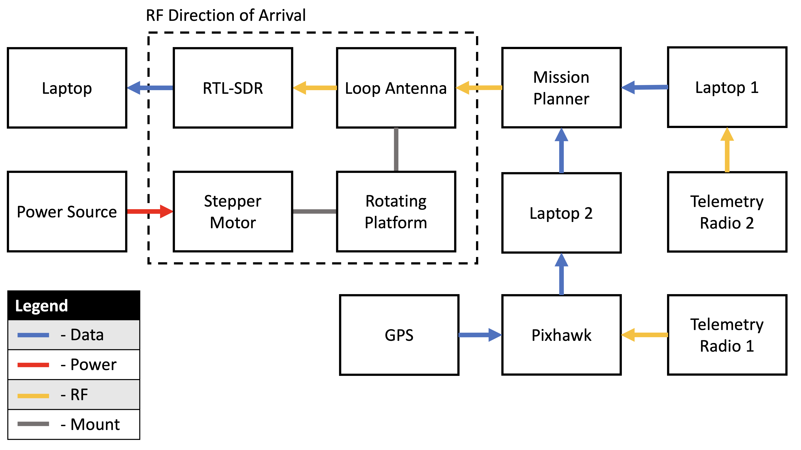

**Figure 1: System Architecture**

The RF Direction of Arrival System is composed of four main sections: a stepper motor, a rotating platform, a loop antenna, and RTL-SDR receivers.

* The stepper motor will be powered by an external power supply. Its main function is to rotate 180° with the antenna platform mounted on top.
* The rotating platform is mounted on top of the stepping motor and will hold the loop antenna in place. This will allow the loop antenna to rotate with the stepper motor.
* The loop antenna is a circular 50Ω coaxial cable with a circumference of 2.7541 cm. The antenna will have a center frequency at 915 MHz but will also function in the entire 33-cm RF band (902-928 MHz). This loop antenna will send its receiving signals to the RTL-SDR .
* The RTL-SDR is a USB dongle plug-in to SMA connector. It is meant to receive antenna signals and display those signals on the SDR Sharp Airspy software. The RTL-SDR will be plugged into an external laptop, and the SDR software will also run on the same laptop.

### **Design Constraints**

To increase productivity and decrease design/testing cost, the system will utilize a drone without the frame or motors. It will consist of a Pixhawk flight controller, GPS, and radio transmitter. Mission planner, an external software, will be used to pair the transmitting and receiving radios to allow for real-time signal transmission. This cuts out the need to spend time creating a detailed simulation while also allowing for real-world signal transmission.

The telemetry radios are designed to operate using FHSS, which makes the signal hard to track. Decreasing the number of channels within which the signal hops and choosing a maximum and minimum frequency in the 33-cm band helps having a better view of the emitted signal.

### **Future Contingencies**

The telemetry radios are pre-programmed to operate on FHSS. We are currently working to mitigate the frequency hopping by reducing the number of hopped channels to 1, but there is the possibility of a contingency in the future if the code is not alterable.

The current loop antenna will be redesigned with antenna shielding and unbalanced to unbalanced connections. If a loop antenna proves to be a contingency with inconsistent results, the project may shift its focus away from loop antennas and towards dipole or Yagi antennas.

## Document Organization

This System Design Document details the system architecture in a high-level manner. It will briefly discuss the hardware and software system architecture. Along with the Human-Machine Interface where the inputs and outputs will be discussed. After that, there will be a detailed design section where it goes further into the hardware and software design aspects of the system. It will conclude with a short section discussing the integrity controls of the system.

## Project References

1. ARDUINO CNC SHIELD CONTROL STEPPER. [Online]. Available: <http://aconcaguasci.blogspot.com/2016/11/arduino-cnc-shield-control-stepper.html>. [Accessed: 21-Sept-2020 through 24-Nov-2020].
2. CNC ARDUINO SHIELD. [Online]. Available: <https://courses.ideate.cmu.edu/16-375/f2017/text/resrc/cnc-shield.html#nema17-stepper-motor>. [Accessed: 28-Oct-2020 through 24-Nov-2020].
3. LECTURE 11: LOOP ANTENNAS. [PDF]. Available: <http://www2.elo.utfsm.cl/~elo352/biblio/antenas/Lectura%2011.pdf>. [Accessed: 11-Sept-2020 through 24-Nov-2020].
4. HANDHELD DIRECTION-FINDING LOOP ANTENNA FOR RFI LOCATION. [PDF]. Available: <http://www2.elo.utfsm.cl/~elo352/biblio/antenas/Lectura%2011.pdf>. [Accessed: 11-Sept-2020 through 24-Nov-2020].

## Glossary

DOA -Direction of Arrival

MHz - Mega Hertz

dB- Decibel

RF- Radio Frequency

SDR - Software Defined Radio

FHSS – Frequency Hopping Spread Spectrum

CNC – Computerized Numerical Control

# SYSTEM ARCHITECTURE

## System Hardware Architecture

Refer to Figure 1, for system architecture. The following is the

* Pixhawk – GPS and transmitter radio connect to the Pixhawk. Pixhawk tells transmitter what data to send to the ground station, receiver radio.
* GPS
* Radios, transmitter and receiver
* Stepper motors - Stepper motors are connected to Arduino board for programming and power and connected to 3D-printed platform holding the antenna.
* Antenna - Antenna is connected to the stepper motor via 3D-printed platform with a space to feed cable through to connect to SDR.

## System Software Architecture

**Rotating Platform**

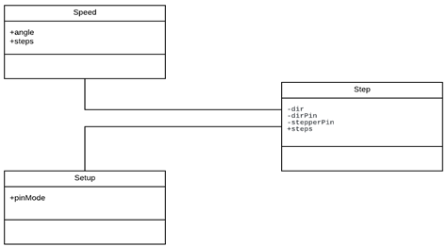

**Figure 3: Class diagram of the rotating platform**

The rotating platform allows the loop antenna attached to it to rotate at the speed and directions set by the user. The simple code to run the stepper motor is explained in the diagram below. Note that this is not a traditional class diagram as used in software development, since the code is so simple.

* Speed: Controls the speed of the rod attached to the stepping motor and returns the angle at which it is currently at.
* Setup: Assigns the X, Y, Z directions to the corresponding pins on the CNC and Arduino Uno boards.
* Step: The main function that outputs the angle on the serial port and transmits the speed and direction to the stepping motor.

# HUMAN-MACHINE INTERFACE

## **Inputs**

* **3.1.1 Mission Planner**

To perform the simulation of the drone the operator Pixhawk and Mission Planner are utilized. To do this, the Pixhawk device is attached to a telemetry radio and connected to the computer running Mission Planner. Once in Mission Planner, in the upper right-hand corner of the interface allows for customization of the type of connected device before connection. To establish the connection, the connect button shown in Figure ??? Below is used.

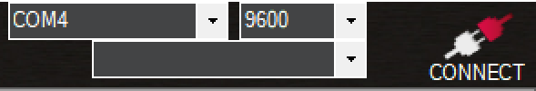

**Figure 4: Customization of the type of connected device before connection**

Once the connection is secure, the upper-right hand corner of the interface part of the interface will appear as the figure below.



**Figure 5: Customization of the type of connected device after connection**

### **3.1.2** **Arduino & Stepping Motor**

To turn the system on, plug in the Arduino board that is connected to the stepping motor and the 12-volt battery supply, to the Laptop, and upload the preexisting code. This will start the stepping motor and begin to rotate the loop antenna that is connected to the rotating platform.

## **Outputs**

## **3.2.1 Mission Planner**

When running a Mission Planner, the user will be presented with a simulation window. This simulation will display a simulation of the virtual done including flight parameters and projected flight path. The flight parameters given include altitude, ground speed, distance to WP, yaw, vertical speed, and the distance to MAV on the first tab of parameters. Additional information about the flight and flight path can be found both on the additional tabs in the bottom right part of the interface, and within the simulated flight view in the top right part of the interface. The user with the second Pixhawk setup can see the changes in the drone’s screen in real time.

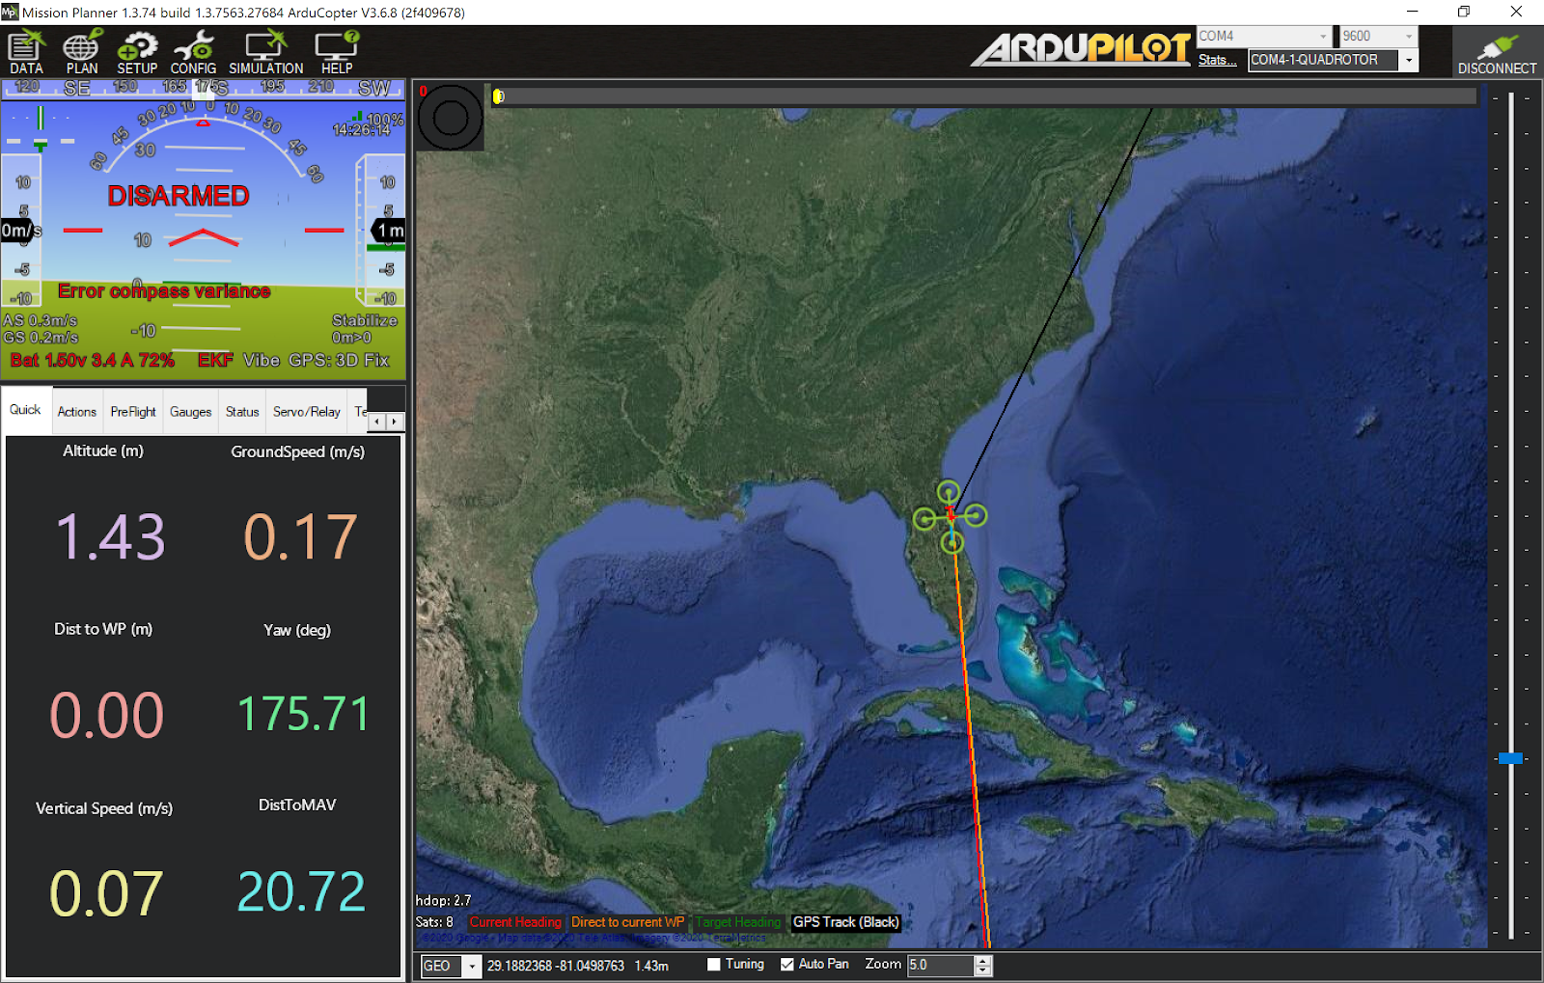

**Figure 6: Mission Planner**

**3.2.2 Airspy**

When running Airspy, the user will be presented with a graphical representation of the signals emitted by the transmitter and exchanged with the ground station. Using the loop antenna connected to the RTL-SDR dongle, the user will be able to see, in real time, the signal’s fluctuation in the chosen frequency band, here the 33 cm band expanding between 902 and 928 MHz. The interface of Airspy helps the user play and stop the signal’s emission, change the speed of the emission, isolate the concerned bandwidth and when applicable, listen and filter noise out of to the audio radio signals exchanged on the chosen frequency.

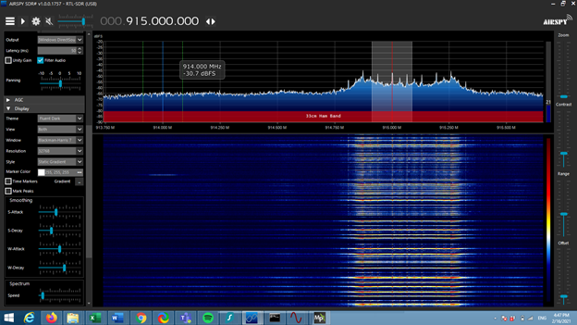

**Figure 7: Airspy display of telemetry radios communications between 914.75Hz and 915.5MHz**

# DETAILED DESIGN

## **Hardware Detailed Design**

This section aims to depict the RF Direction Detection physical system functionality through detailed design models of the rotating platform/stepping motor, loop antenna, and the SDR. This will clarify the connections between all three systems.

### **4.1.1** **Rotating Platform & Stepping Motor**

The stepping motor consists of the CNC shield attached to the Arduino Uno. The motor is wired to the CNC shield and with a 12-volt battery supply. Attached to the rod of the motor is the rotating platform. The rotating platform is 3D modeled and printed. The following figures describe the schematics, wiring, and dimensions of the stepping motor and rotating platform.

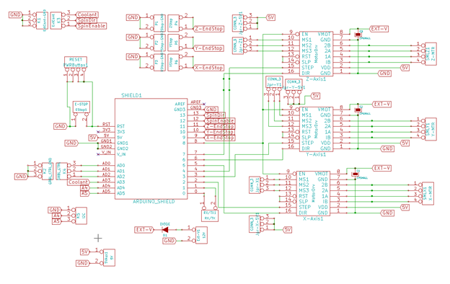

**Figure 8: Pin mapping and wiring of the CNC shield**

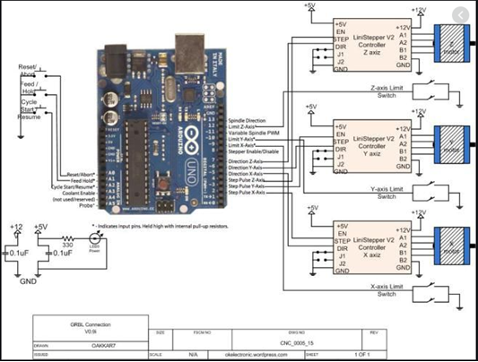

**Figure 9: Pin mapping and wiring of the Rotating Platform on Arduino Uno Board**

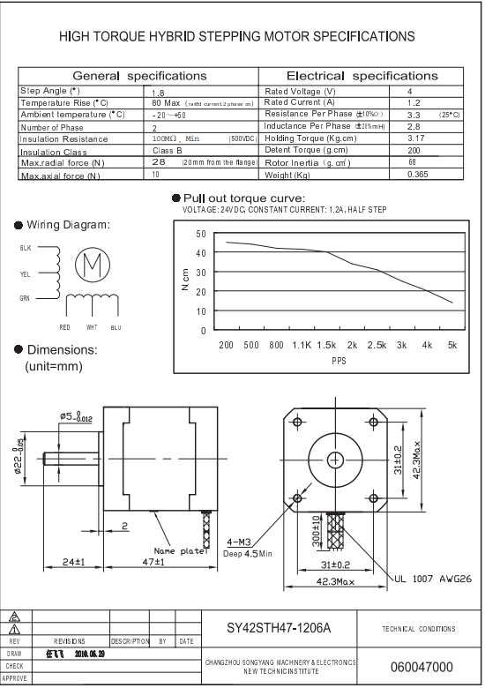

**Figure 10: Datasheet of the Nema 17 Stepper Motor connected to the CNC shield**

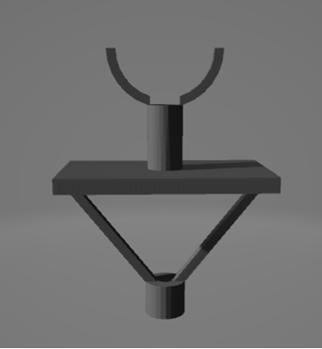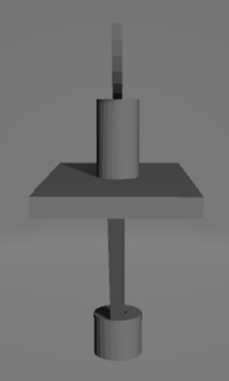

**Figure 11: AutoCAD drawing of the rotating platform**

### **4.1.2** **Loop Antenna**

The loop antenna will be approximately 32.7 mm in diameter, 10% of the target wavelength. At 915 MHz, the wavelength is about 32.7 cm. To make a magnetic/electrically small loop antenna, the largest linear dimension (diameter) must be 1/10 of the wavelength. The antenna must be made out of a conductive material, in this case, copper. The loop is created and then soldered onto the end of a copper wire with a male SMA connector at the opposite end to connect to the SDR. When the incoming signal is perpendicular to the plane of the loop, the received signal gain will display a sharp drop

**4.1.3 RTL-SDR**

The RTL-SDR is a USB dongle that works with the Airspy software. It is composed of one USB port to connect it to the laptop and one female SMA connector to connect an antenna.

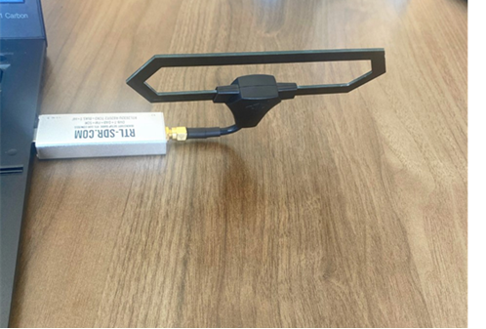

**Figure 12: RTL-SDR (silver) USB dongle connected to laptop with test diamond antenna**

**4.1.4 GPS**

The PixHawk GPS module is connected to the Pixhawk by a 4-wire cable.

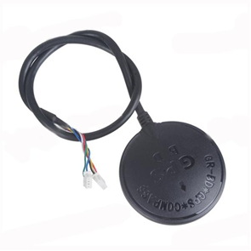

**Figure 13: PixHawk GPS**

## **Software Detailed Design**

This section is not applicable as there is no major software component of the system. The Rotating platform basic software to control speed and directions and printing the angle of the loop has been described in the System Software Architecture section of the SDD

## **Internal Communications Detailed Design**

The RTL-SDR transcribes the signal received by the loop antenna into a visual representation of the signal’s spectrum, displaying the gain in dB and the frequency in MHz. This signal is emitted by the telemetry radios, transmitting and receiving flight pattern’s information from the PixHawk flight controller.

# EXTERNAL INTERFACES

The other system that works alongside the RF Directions Detection system will be any drone within the area. There is no system that needs to work simultaneously with the RF Direction Detection system. The RF Direction Detection system is scanning for drones within the area if it does not find one then there are no drones in the area.

**5.1** **Interface Architecture**

The communication between the drone in question is described in the Human-Machine Interfaces Input section of the SDD. The frequency the drone runs on will be scanned by the loop antenna and the software-defined radio. Once detected by the system the Rotating Platform will stop so the loop antenna and software design radio can continue receiving the signal of the drone and display

# SYSTEM INTEGRITY CONTROLS

There is no sensitive information to the software or hardware of the system. The system will be available to students of the Embry Riddle Campus to demonstrate RF Direction Detection. The general public will be provided with the information and design of the system.